DAY 4 - BUILDING DYNAMIC FRONTENDCOMPONENTS
FOR YOUR MARKETPLACE”

1. The product listing page with dynamic data

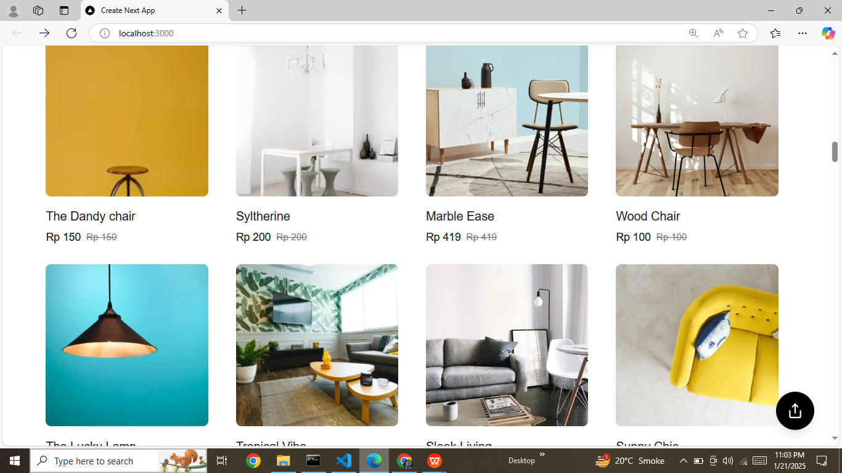

2.Individual product detail pages with accurate routing and
data rendering.

- Working category filters, search bar, and pagination
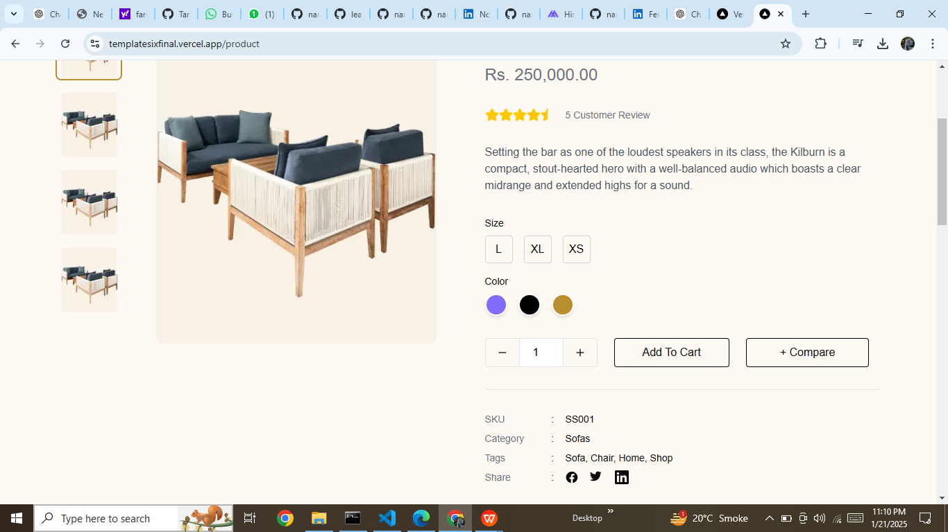

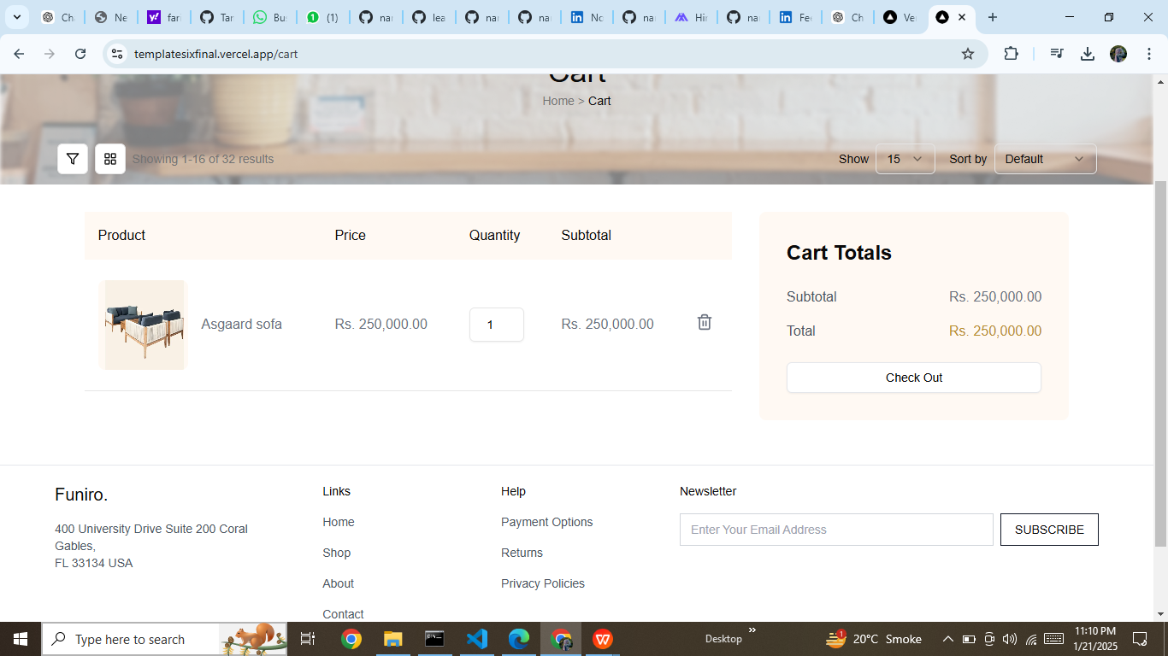

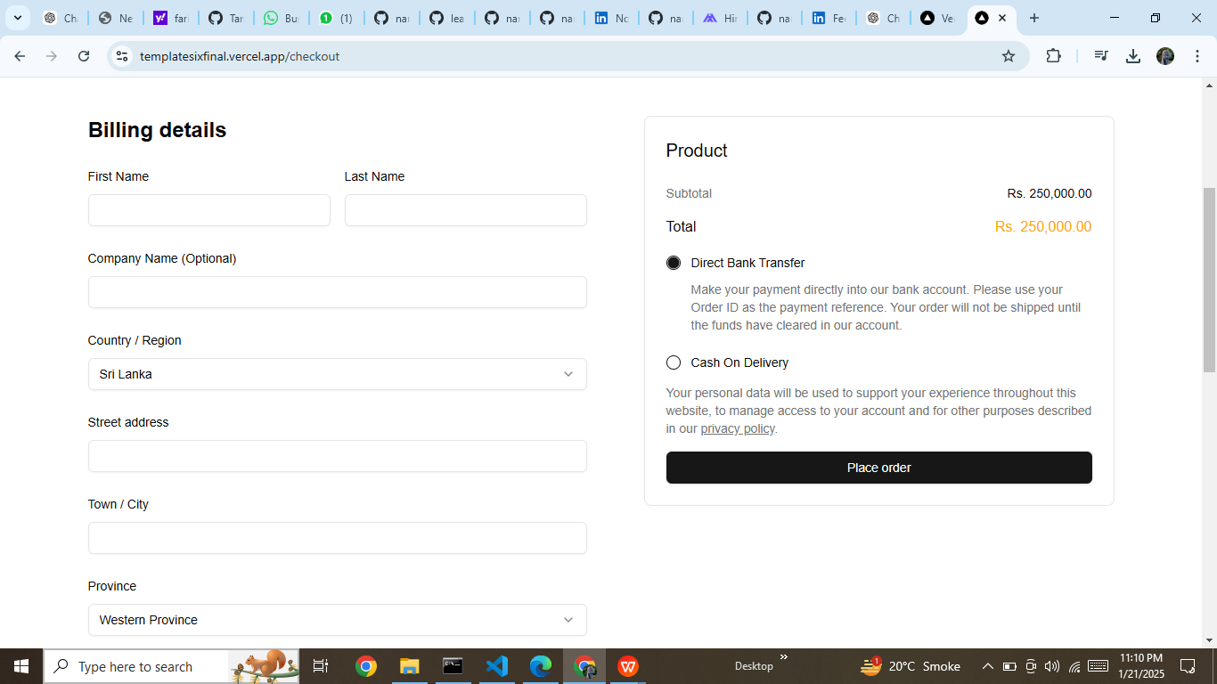

PRODUCTCARD.SNIPPET

import Image from 'next/image';
import Link from 'next/link'; // Import Link for navigation
import { Heart, Share2, LayoutGrid } from 'lucide-react';
import { Product } from '../types/product';
import { urlFor } from '@/sanity/lib/image';

type ProductCardProps = {
product: Product;
};

const ProductCard = ({ product }: ProductCardProps) => {
const formatPrice = (price: number) => {
return `Rp ${price.toLocaleString()}`;
};

return (
<Link href="/product">
<div className="group relative flex flex-col">
<div className="relative aspect-square w-[95%] overflow-hidden rounded-lg bg-gray-100">
<Image
src={urlFor(product.productImage).url()}
alt={product.title}
className="object-cover"
fill
sizes="(min-width: 1024px) 25vw, (min-width: 768px) 33vw, 50vw"
/>
{/* {product.tag && (
<div
className={`absolute right-3 top-3 rounded-full px-3 py-1 text-sm font-medium text-white
${product.tag.type === 'discount' ? 'bg-rose-500' : 'bg-emerald-500'}`}
>
{product.tag.type === 'discount' ? product.tag.value : 'New'}
</div>
)} */}
<div className="absolute inset-x-0 bottom-0 bg-white/75 p-4 opacity-0 transition-opacity-50 group-hover:opacity-100">
<button className="w-full rounded bg-black py-2 text-sm font-medium text-white hover:bg-black/90">
Add to cart
</button>
<div className="mt-2 flex items-center justify-center gap-4 text-sm text-gray-700">
<button className="flex items-center gap-1 hover:text-black">
<Share2 className="h-4 w-4" />
Share
</button>
<button className="flex items-center gap-1 hover:text-black">
<LayoutGrid className="h-4 w-4" />
Compare
</button>
<button className="flex items-center gap-1 hover:text-black">
<Heart className="h-4 w-4" />
Like
</button>
</div>
</div>
</div>
<div className="mt-4 flex flex-col">
<h3 className="text-lg font-medium text-gray-900">{product.title}</h3>
{/* <p className="mt-1 text-sm text-gray-500">{product.category}</p> */}
<div className="mt-1 flex items-center gap-2">
<span className="font-medium">{formatPrice(product.price)}</span>
{product.price && (
<span className="text-sm text-gray-500 line-through">
{formatPrice(product.price)}
</span>
)}
</div>
</div>
</div>
</Link>
);
};

export default ProductCard;

PRODUCTLIST.TSX SNIPPET

import React from 'react';
import ProductCard from "./ProductCard";
import { Product } from "../types/product";
import Link from "next/link";
import { client } from "../../sanity/lib/client";

// const Products = () => {
// const products: Product[] = [
// {
// id: '1',
// name: 'Slytherine',
// category: 'Stylish cafe chair',
// price: 2500000,
// originalPrice: 3500000,
// image: '/f1.png',
// tag: {
// type: 'discount',
// value: '-30%'
// }
// },
// {
// id: '2',
// name: 'Leviosa',
// category: 'Stylish cafe chair',
// price: 2500000,
// image: '/f7.png',
// },
// {
// id: '3',
// name: 'Lolito',
// category: 'Luxury big sofa',
// price: 7000000,
// originalPrice: 14000000,
// image: '/f3.png',
// tag: {
// type: 'discount',
// value: '-50%'
// }
// },
// {
// id: '4',
// name: 'Respira',
// category: 'Outdoor bar table and stool',
// price: 500000,
// image: '/f4.png',
// tag: {
// type: 'new'
// }
// },
// {
// id: '5',
// name: 'Grifo',
// category: 'Night lamp',
// price: 1500000,
// image: '/f5.png',
// },
// {
// id: '6',
// name: 'Muggo',
// category: 'Small mug',
// price: 150000,
// image: '/f6.png',
// tag: {
// type: 'new'
// }
// },
// {
// id: '7',
// name: 'Pingky',
// category: 'Cute bed set',
// price: 7000000,
// originalPrice: 14000000,
// image: '/f7.png',
// tag: {
// type: 'discount',
// value: '-50%'
// }
// },
// {
// id: '8',
// name: 'Potty',
// category: 'Minimalist flower pot',
// price: 500000,
// image: '/f7.png',
// tag: {
// type: 'new'
// }
// },
// ]

// return (
// <div className="mx-auto max-w-7xl px-5 py-12 sm:px-6 lg:px-16">
// <h2 className="mb-8 text-center text-2xl font-bold text-gray-900">Our Products</h2>
// <div className="grid grid-cols-1 gap-7 justify-center items-center sm:grid-cols-2 lg:grid-cols-4">
// {products.map((product) => (
// <ProductCard key={product.id} product={product} />
// ))}
// </div>
// <div className="mt-12 flex justify-center">
// <Link href="/shop" >
// <button className="rounded-sm border border-[#B88E2F] px-8 py-4 text-sm font-medium text-[#B88E2F] hover:border-gray-400 hover:text-gray-900">
// Show More
// </button>
// </Link>
// </div>
// </div>
// )
// }

// interface Product {
// _id: string;
// title: string;
// price: number;
// discountpercentage: number;
// tags: string[];
// productImage: {
// asset: {
// _ref: string;
// };
// };
// description: string;
// available: boolean;
// }

async function fetchProducts(): Promise<Product[]> {
const query = `*[_type == "product"] {
_id,
title,
price,
discountPercentage,
tags,
productImage {
asset {
_ref
}
},
description,
available
}`;
return client.fetch(query);
}

const Products = async () => {
const products = await fetchProducts();
return (
<div className="mx-auto max-w-7xl px-5 py-12 sm:px-6 lg:px-16">
<h2 className="mb-8 text-center text-2xl font-bold text-gray-900">
Our Products
</h2>
<div className="grid grid-cols-1 gap-7 justify-center items-center sm:grid-cols-2 lg:grid-cols-4">
{products.map((product) => (
<ProductCard key={product._id} product={product} />
))}
</div>
<div className="mt-12 flex justify-center">
<Link href="/shop">
<button className="rounded-sm border border-[#B88E2F] px-8 py-4 text-sm font-medium text-[#B88E2F] hover:border-gray-400 hover:text-gray-900">
Show More
</button>
</Link>
</div>
</div>
);
};

export default Products;

